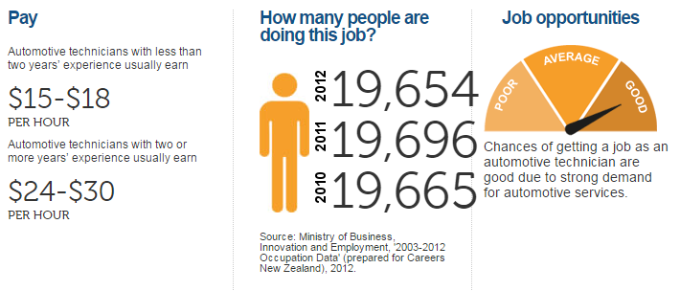
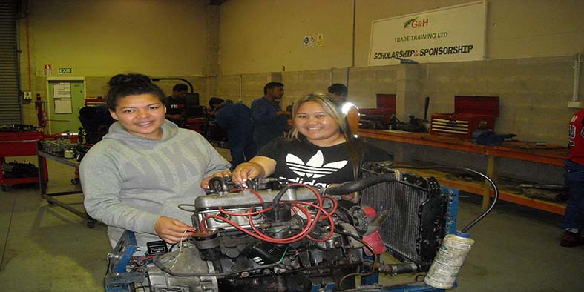
Automotive (Level 2) – Available in East Tamaki & Lower Hutt
This course is a great way to explore an interest in the automotive industry, while gaining credits towards your NCEA level 2!
You will attend G&H Training one day a week and will get the opportunity to gain at least 20 credits towards NCEA Level 2. You will get the opportunity to complete practical tasks to assist your learning and understanding of the theory assessments.
This course can:
- Start you on the pathway towards a career as a mechanic or other automotive related jobs.
- Gain you priority entry onto G&H Training’s Motor Industry (Entry) Skills Course at Level 2 or
Certificate in Automotive Servicing Course at Level 3 (available in Wellington only)

Statistics about working in the automotive industry:

If you have any questions or would like further information, please contact:
Kathryn Smith at Te Kura
Phone: 0800 65 99 88, Extension: 8552
Email: huarahi@tekura.school.nz
Huarahi Trades Academy

