**Setting up AVG anti-virus software on a Te Kura-issued laptop**

To protect you and everyone you interact with Te Kura has installed AVG anti-virus software on the laptop. You will need to configure the software to run scans on your laptop.

Click on <http://features.en.softonic.com/how-to-set-up-avg-antivirus-2015-for-optimal-protection> and follow the instructions.

**Making sure AVG is up to date**

AVG automatically updates on a regular basis, ensuring that the protection is always up to date. If you need to make sure that you have the latest updates installed, you can start the update process manually.

**A. Update AVG from the Internet**

1. Open AVG program.
2. Click Update now.

If there are new update files available, AVG will download these files and update itself automatically.

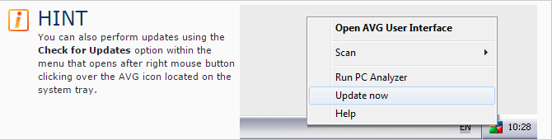

**B. Updating AVG offline (from a local directory)**

If you need to update your AVG from local disk (e.g. when the Internet connection is not available) follow these steps:

1. Go to [www.avg.com/update](http://www.avg.com/update).
2. Select the update files you need (typically Virus definitions and All necessary modules for your operating system) and download them to a portable media, e.g. a USB flash disk.
3. Open your AVG program.
4. In the menu Options, click Update from directory.
5. Navigate to the folder where you stored the update files, and click OK.