***Editor’s letter***

Welcome supervisors.

I can hardly believe it is the middle of the year already. For those of us who are heading into the winter months you will no doubt be stoking up those fires. I envy those overseas students who are getting ready to sun themselves!

There are a variety of tips for you this term and a lovely art activity suitable for all ages, to help you get creative.

This term we also find out what Arts Curriculum Leader, Jan Bolton has been up to and you will learn how your student can contribute to the chorus of a Te Kura video production. My son feels very proud to have contributed to this already and is looking forward to the end result.

We were recently at a regional event day where we had a wonderful fun packed day. I encourage you and your student to attend these days if you are able, as they are a great way for the students to interact with each other and meet new friends. There is usually a supervisor session as well which gives you a chance to discuss any difficulties you may be facing as well as bounce ideas off each other. The learning advisors put a huge amount of effort into these events so support them if you can.

Warm wishes to you all and enjoy the rest of the term.

*Dianne*

*A child seldom needs a good talking to as a good listening to – Robert Brault*

***Te Kura Supervisor Newsletter***

***Years 1 to 10 and Special Education***

***2013 Term 2***

***Issue 8***

***Contents***

Te Kura Library

Te Kura Early Childhood

Information and Tips

Ali’s Art Corner

* Card making

Hello from Adele

* Keep Moving

*Clipart for this publication – Microsoft Office Online Clipart*

Please email your ideas to: [diannestephens@farmside.co.nz](mailto:diannestephens@farmside.co.nz) with *supervisor newsletter* in the subject line. We look forward to hearing from you.

2

2

2

3

4

3

4

***SUPERVISOR PAYMENT***

A reminder to all supervisors to ensure that Te Kura has your correct bank account details so your midyear supervisor payment can be deposited without delay. <http://www.tekura.school.nz/supervisor-toolkit/supervisor-payment>



**We want to hear from you so email your contributions or questions to either myself or Adele with the subject title: *Supervisor Newsletter*** [adele.harris@tekura.school.nz](mailto:adele.harris@tekura.school.nz)

1

Te Kura Library

Join Te Kura Library and enjoy a huge selection of material. The friendly helpful librarians are happy to discuss your requirements either over the phone or through email and will post items to you.

[Login](https://www.correspondence.school.nz/Oliver/LibraryOliver/gateway/gateway.exe?application=LibraryOliver&displayform=frame) to the library home page or go to [Using the library](http://www.tekura.school.nz/student-toolkit/using-the-library) for more information and fabulous online resources.

Adele also has a vast knowledge of helpful books for supervisors so email her for some titles.

You can contact the library on:

Ph 0800 65 99 88 ext 8783 or 8502 or Email: [library@tekura.school.nz](mailto:library@tekura.school.nz)

**National Standards**

Ever wondered where your student should be with their learning? Here are two links to the National Standards for you to check out. If you have never been into the TKI website then have a good look as there is a wealth of information there for you.

[Reading and Writing Standards](http://nzcurriculum.tki.org.nz/National-Standards/Reading-and-writing-standards/The-standards)

[Mathematics Standards](http://nzcurriculum.tki.org.nz/National-Standards/Mathematics-standards/The-standards)





**Mathletics**

Is your student enrolled in [Mathletics](http://www.mathletics.co.nz)? If so then please make the most of this wonderful resource that Te Kura has made available to you. It is great to use as a warm up before a maths lesson or as a fun way to end one. There is also the incentive of gaining a certificate at the end of each week if they reach the points required!

**Supervisor toolkit**

The [supervisor toolkit](http://www.tekura.school.nz/supervisor-toolkit) on the Te Kura website is a must for all supervisors to peruse. There is everything you need to know to assist with your role as a supervisor and this term I would like to highlight the E-Learning page. This page gives information to e-learning students or for those who have an e-learning component in their course. There are also helpful links to staying safe on the Internet which is a must see for all students who use a computer.

**Kids safe search engines**

If you are looking for safe search engines for your students then you might like to look at these three:

* [Kidrex](http://www.kidrex.org/)
* [Quintura for kids](http://quinturakids.com/)
* [Kigose](http://www.kigose.com/)

**Useful links**

If you are stuck for fun ideas for teaching [dictionary skills](http://www.teachingideas.co.uk/english/contents.htm), here is a website which is easy to use with downloadable word or pdf sheets. There is also a range of reading activities as well which makes a bit of something for everyone.



**Te Kura’s Early Childhood website**

Have you discovered Te Kura’s [Early Childhood](http://www.correspondence.school.nz/ech/) website? It is absolutely delightful and has everything you need to know. It show- cases the staff and their profiles, ideas, art, activities, stories, music, a gallery of the children’s art work, which is a pleasure to see and so much more. Even if you haven’t got a preschooler you will love this site!

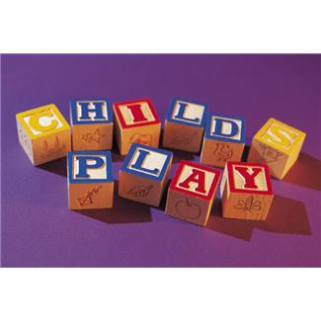

2

**Ali’s Art Corner**





[**Tiny Treasures Cards**](http://www.momincdaily.com/designing-moms/make-tiny-treasure-cards/)

Here is an idea for card making that will suit all ages, genders and occasions and makes good use of those little treasures that we all collect over time. The link to the website gives you full instructions on how to make these wonderful cards.

The measurements given may be a bit small for younger students so just adjust accordingly to make the card size of your choice.

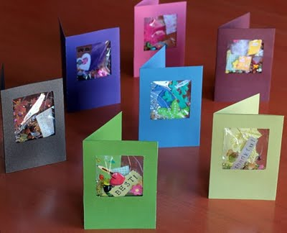 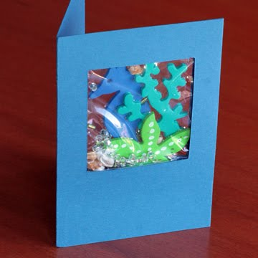

<http://www.momincdaily.com/designing-moms/make-tiny-treasure-cards/>

**Treasure ideas**

* paper and foam stickers
* leaves or flowers, silk or dried
* beads
* large glitter
* sequins
* Ribbons
* confetti
* die-cut decorations
* feathers
* shells
* alphabet stickers, rubber stamps
* pipe cleaners
* fabric swatches
* buttons
* trinkets/charms
* faux jewels
* specialty papers
* sea glass
* children’s drawings or doodles

**Possible card themes**

* New Year
* valentine’s/love
* new baby
* birthday
* Easter
* 4th of July
* graduation
* mother’s/father’s day
* grandparent’s day
* halloween
* thanksgiving
* hanukkah
* Christmas
* thinking of you
* teacher
* get well
* bon voyage
* sports

3

**Hello from Adele**

My name is Adele Harris.

I am available by phone or email during term time to discuss or suggest any ideas that may help you in your role as a supervisor [adele.harris@tekura.school.nz](mailto:adele.harris@tekura.school.nz)

Ph 0800 65 99 88 Ext 8244

MC900438185[1]MC900446384[1]

**Keep Moving**

Have you checked out this exciting musical experience for your students?

<http://www.tekura.school.nz/student-toolkit/keep-moving>

Arts Curriculum Leader, Jan Bolton, has been working on a project to bring to life the original music of two talented Te Kura students, Bryony Greene and Jae Herekiuha. We still need students, current and former, (age no barrier) to add their voices to the chorus of this great song. This is a great opportunity for your students (current or former), to be a part of this groundbreaking Te Kura video production.

The instructions on the Te Kura website (above) are easy to follow. If you need some reassurance just contact your student’s teacher or myself, and we will be happy to help you.

Currently:

* Work is underway to design, record and produce the music video.
* Student Henry Leckie-Hodge has been chosen as the videographer.
* The project has a prestigious invitation to be featured at the National Arts Conference in Auckland at end of June.

<http://www.creativenz.govt.nz/en/arts-development-and-resources/national-arts-conference-2013>

* Jan Bolton will lead the presentation and, Bryony, Jae and Henry will be present and actually meet each other for the first time!

Here is the latest “mock up” <http://safeshare.tv/w/VDpJSNwTzC> Enjoy…

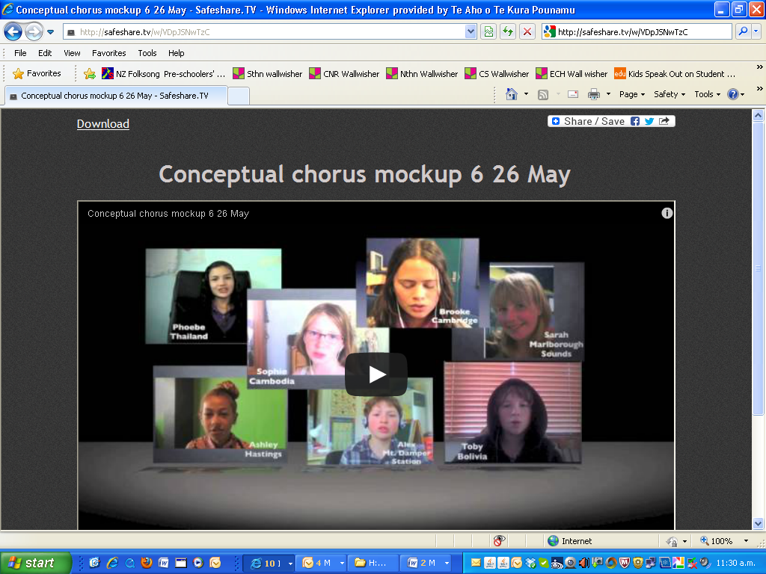

4

This newsletter for supervisors was written by supervisors of Te Kura students. The views expressed in this newsletter are those of the supervisors who contributed to it.