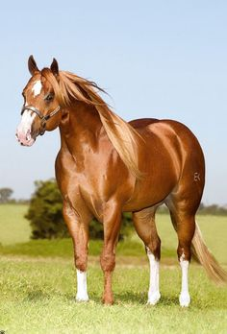
EQUINE DISTANCE LEARNING
Do you own or work with horses?
Is a career in the Equine Industry something you would consider?

Te Aho o Te Kura Pounamu can offer you the opportunity to study unit standards in Equine.

Level 1
Unit Standard | Description | Credits
1658^ | Demonstrate knowledge of the nature and requirements of a career in the equine industry | 3
Level 2
Unit Standard | Description | Credits
14590* | Demonstrate knowledge of preparing and attending to horses when transported by air | 2
14594^* | Identify signs of good health and ill health in horses | 4
1602^ | Demonstrate knowledge of the Harness racing industry structure | 3
19949^* | Identify basic components and functions, and common problems of horses' body systems | 4
23645^ | Demonstrate knowledge of the nature of horses | 3
Level 3

Unit Standard | Description | Credits
6611^* | Demonstrate knowledge of the procedure for bringing a horse into work after a spell and letting down | 3
6612^* | Identify plants, grasses, and trees which are potentially poisonous to horses, and describe methods of removal | 3
6613^ | Demonstrate knowledge of the structure of the horse’s foot, the horses shoeing process and remedial shoeing | 4
6617 | Assess stable design and construction | 3
23644^ | Demonstrate knowledge of educating horses | 5
25003^ | Identify horses' anatomy and conformation | 4
25443^ | Demonstrate knowledge of the gear and procedures used in the exercise of horses | 4
25444^ | Describe the rules and effects of problem gambling and drug use in the racing industry | 2
19946^* | Describe features and internal structure of the hoof capsule of the horse | 5
19947^* | Describe the anatomical structure of horse legs | 5
* Available from Telford through SIT
^ Available from NZ Equine Education Trust

If you any questions about these Unit Standards or you would like to enrol please contact ces.lowe@tekura.school.nz

