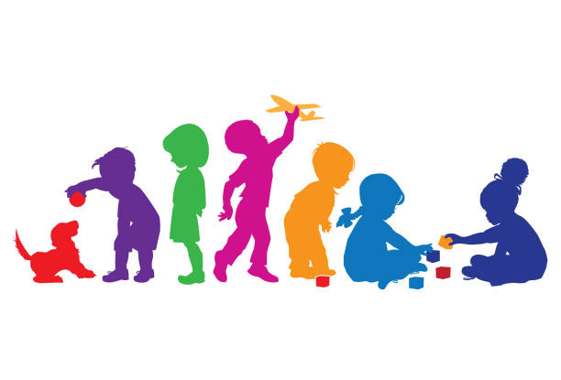**Early Childhood Education (ECE)**

ECE is an exciting career with lots of possibilities including becoming a kaiako, kaiāwhina or carer.These unit standards aim to provide students with the skills in early childhood learning and the care of infants, toddlers and young children.

Te Kura can offer students the opportunity to study ECE via Distance by ordering Level 2 & 3 unit standards through Whānau Āwhina Plunket.

The ECE Tertiary Link Programme is like another subject, but students are limited to completing 12-14 credits for the year (about 3 – 4 unit standards worth).

To be eligible to enrol, students MUST be enrolled with Te Kura as a Full-Time student or a Young Adult doing 3 or more Te Kura subjects. Students must also continue to engage with their Te Kura learning while enrolled in the ECE Tertiary Link Programme.

The work is digital (word documents) and includes a Learner Workbook and Assessment. Both will be emailed directly to students so they can type their answers. The work is open book and self-paced, but the Assessment has to be submitted by the final due date in Term 4. When a student completes their Assessment, they need to email a copy to Lisa who will forward onto Whānau Āwhina Plunket for marking.

If a student prefers working with paper-based materials, printing and postage can be organized by Te Kura. Once a student completes their Assessment, they will need to scan/take a photo of each page of their Assessment and email to Lisa who will forward onto Whānau Āwhina Plunket for marking.

If you have any questions or you would like to enrol, please contact **Lisa Usoali’i-Jansen,** Secondary / Tertiary Advisor via email [Lisa.Usoalii-Jansen@tekura.school.nz](mailto:Lisa.Usoalii-Jansen@tekura.school.nz)

|  |  |
| --- | --- |
| **Important Dates 2025** | |
| **Last day to enrol for 2025** | **Friday 31st October 2025** |
| **Last day to hand in Assessments for 2025** | **Friday 5th December 2025** |

|  |  |  |  |
| --- | --- | --- | --- |
| **LEVEL 2 ECE Unit Standards 2025** | | | |
| **Unit Standard** | **Description** | **Level** | **Credits** |
| **29852**  **(Basic Needs & Nutrition)** | *Demonstrate knowledge of the basic needs and nutrition that support young children's holistic wellbeing and development* | 2 | 4 |
| **29853**  **(Child Health & Wellbeing)** | *Demonstrate knowledge of health issues, practices and services to protect and enhance the wellbeing of young children* | 2 | 4 |
| **29855**  **(Attachment Relationships)** | *Describe attachment behaviours and strategies used to support transitions for young mokopuna/children* | 2 | 3 |
| **29857**  **(Learning & Development)** | *Describe patterns of development and learning for young mokopuna/children* | 2 | 5 |
| **29861**  **(Support Services)** | *Identify and describe agencies/services available to support young mokopuna/children and whānau/families* | 2 | 3 |

|  |  |  |  |
| --- | --- | --- | --- |
| **LEVEL 3 ECE Unit Standards 2025** | | | |
| **Unit Standard** | **Description** | **Level** | **Credits** |
| **10013**  **(Te Whariki)** | *Explain the relevance of the New Zealand Early Childhood Curriculum Te Whāriki as a framework for programme development* | 3 | 2 |
| **10026**  **(Learning & Development)** | *Demonstrate knowledge of mokopuna/children's holistic development and learning in an early childhood setting* | 3 | 6 |
| **29864**  **(Attachment & Transitions)** | *Demonstrate knowledge of attachment theories, behaviours and transition support in an early childhood setting* | 3 | 4 |
| **29865**  **(Health & Wellbeing)** | *Describe and reflect on practices to protect and promote the health and holistic wellbeing of young mokopuna/children* | 3 | 4 |
| **29869**  **(Ethics)** | *Demonstrate knowledge of ethical responsibility to guide practice in an early childhood setting* | 3 | 3 |
| **29871**  **(Philosophies & Services)** | *Describe and compare a range of ECE services and philosophies in Aotearoa New Zealand* | 3 | 3 |