Applications are now open for
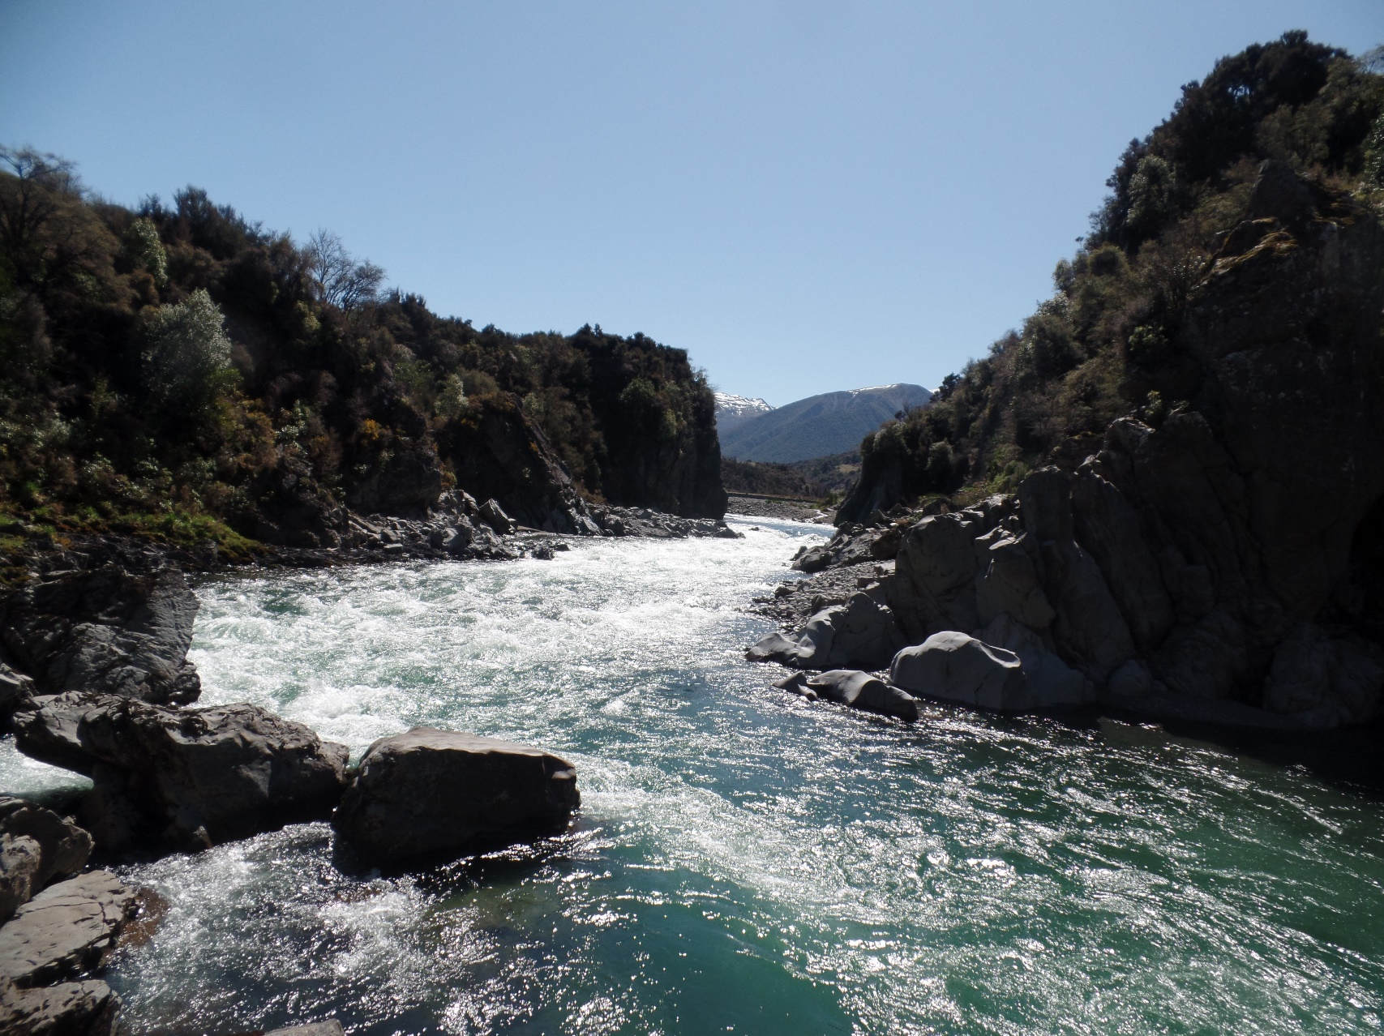
Boyle River Outdoor
Education Camp
14-18 October 2019

Applications close on August 30^{th,} 2019

What is this about?
This is Te Kura’s annual residential camp at Boyle River Outdoor Education Centre, Lewis Pass.
If you are a full time* South Island student at Te Kura, have not been to the Boyle River Camp before, and are in year 11 or above, you are invited to apply to attend this course. There are 20 places available paid for by Te Kura at no cost to students. If you are selected, you will be contacted by Friday 13 September 2019.

The types of activities that you will experience and learn at Boyle River are- Bush Craft, River Crossing, Orienteering, Tramping and Camping, Rock Climbing and much more.
There is also the opportunity for you to gain valuable team work and communication skills as well as achieving unit standards 467, 470 and 473 (9 credits at Level 2).

There will be two Te Kura staff members attending along with the students.

Assistance to help with the cost of overland travel (public or private) is available by submitting a travel claim form after the event.

* Students who are enrolled as Fulltime, or Young Adult and are enrolled in 3 or more subjects or taking an equivalent amount of work with Te Kura in an Authentic Learning Context.

Applications close on August 30, 2019

Further information about the Boyle River Outdoor Education Centre can be found on their website www.boyle.org.nz

What do I do now?
If you wish to apply, please fill out the form at the end of this flyer and send it to me. Do not make any travel bookings until you have been confirmed on the course. Please ring or email me at any time for more information.

All the best,

Chris Berentson– Secondary Tertiary Advisor

ytt@tekura.school.nz

0800 659988 ext. 8479

www.tekura.school.nz

Boyle River Camp 2019 Application Form
This page must be sent to the Secondary Tertiary Adviser- address below.
Surname: First Name:
Student ID:

Questions for student (please write as much as you wish using extra paper if required).
Why do you wish to attend this camp?

What do you hope to gain from the experience?

What personal qualities can you bring to this shared group experience?

Please explain in as much detail as possible why you think you should be chosen to attend this camp.

Send by Email to: ytt@tekura.school.nz

Applications close on August 30, 2019

