Applications are now open for
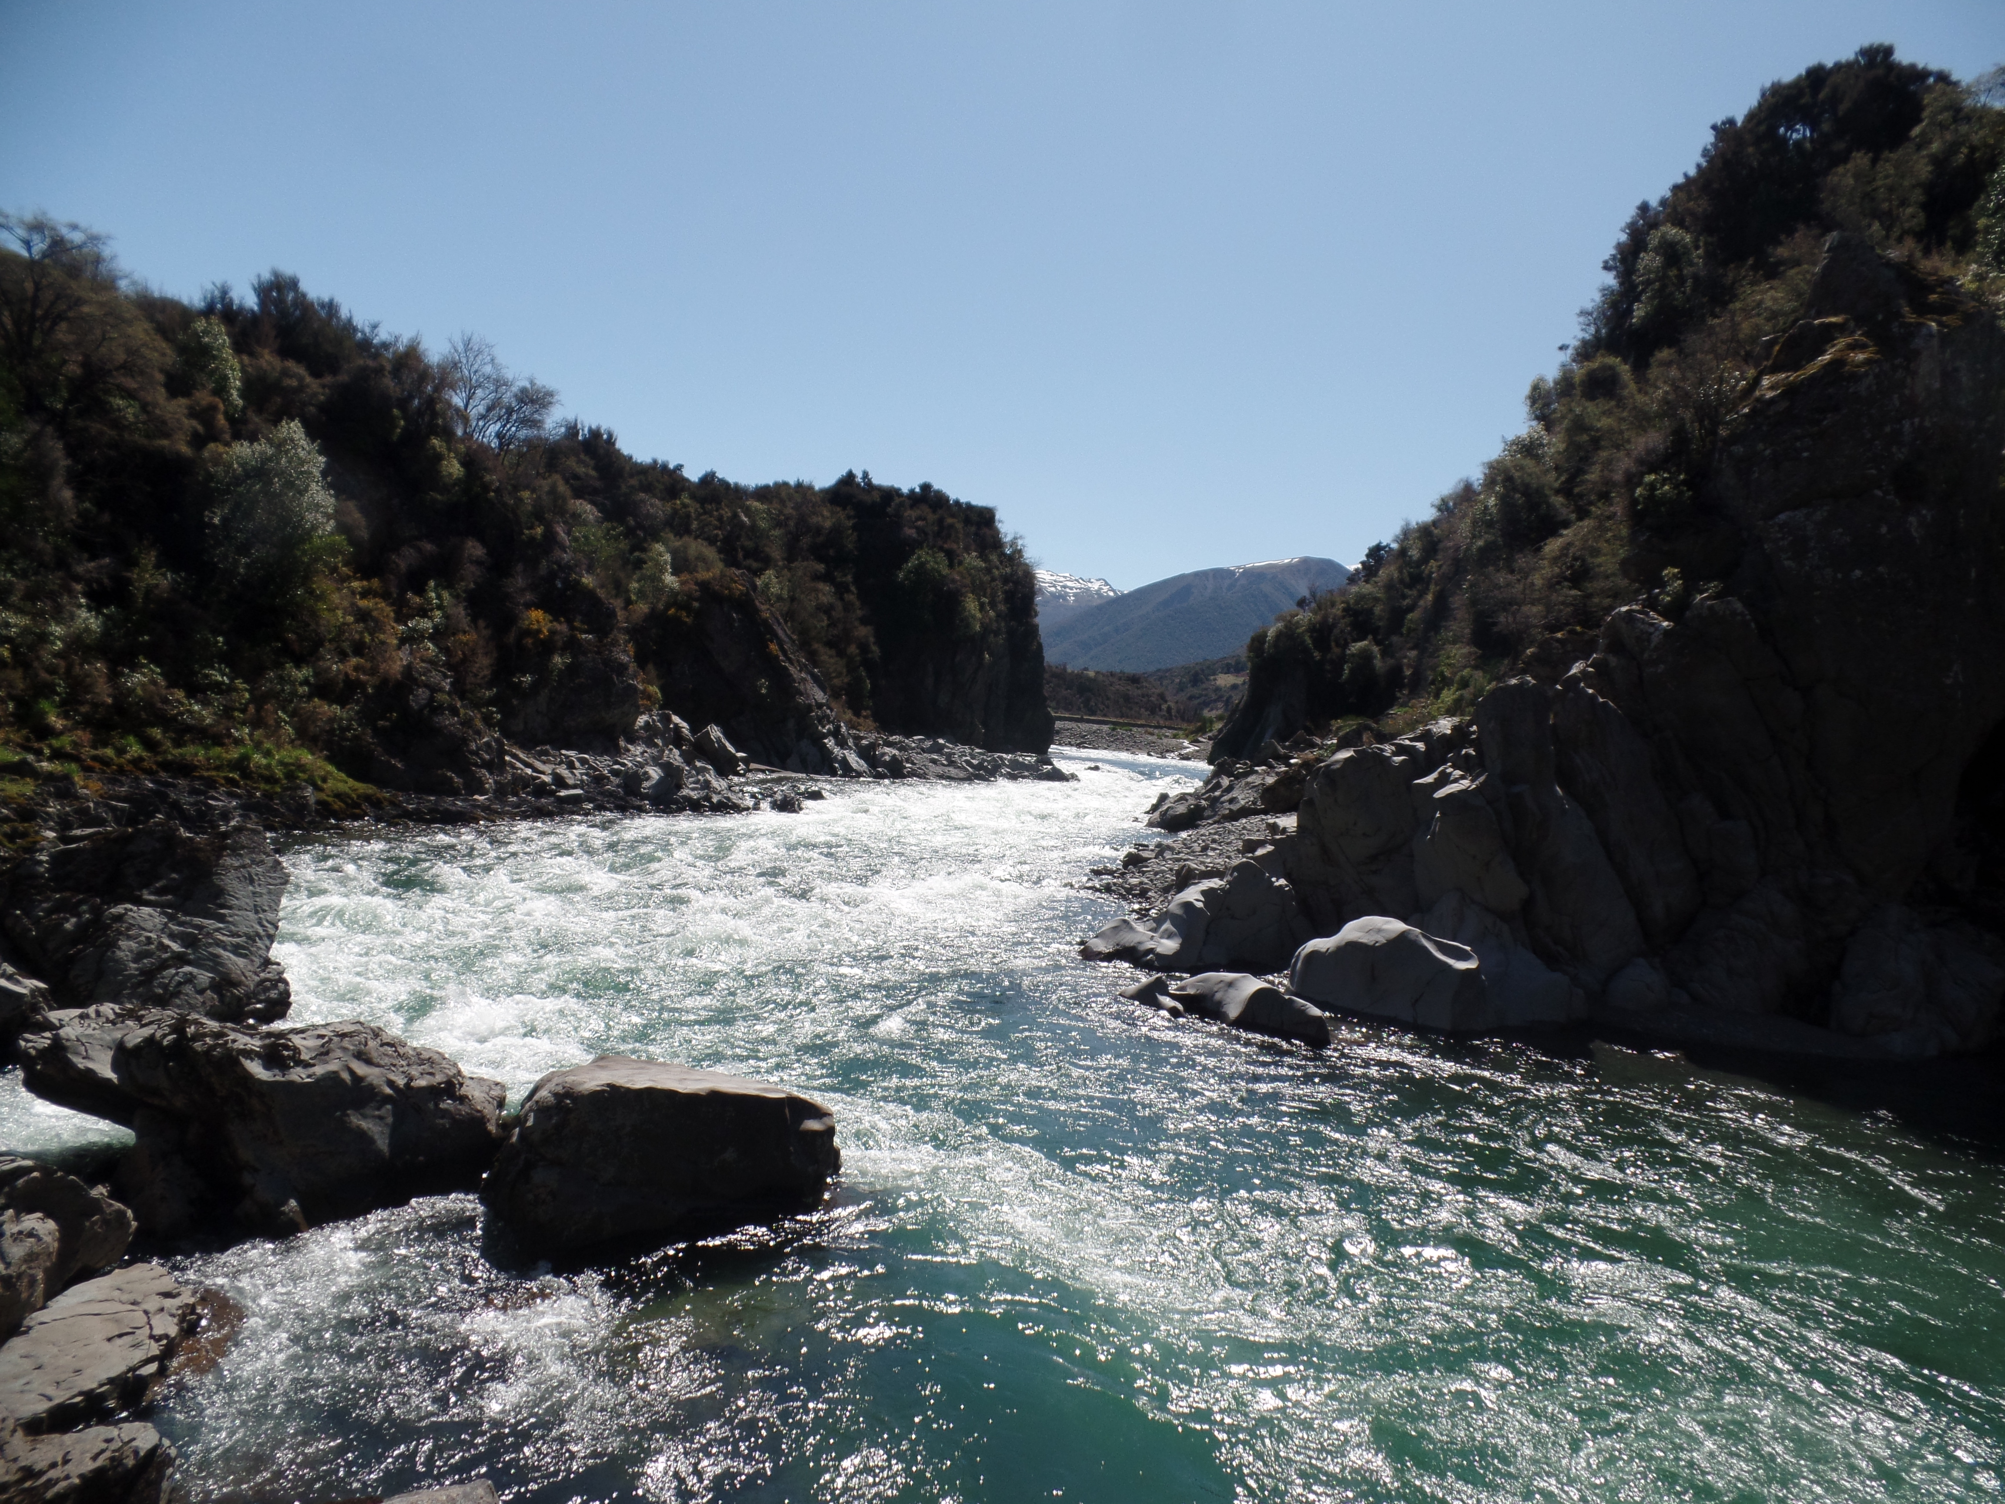
Hillary Outdoors
2019
26 May-31 May 2019

Outdoor Education Camp
At Hillary Outdoors Tongariro

Applications close on April 12th, 2019

What is this about?
This is Te Kura’s annual residential camp at Hillary Outdoors near Mt Ruapehu.
If you are a full time* North Island student at Te Kura, have not been to Hillary Outdoors before, and are in year 11 or above, you are invited to apply to attend this course. There are 20 places available paid for by Te Kura at no cost to students, and if you are selected you will be contacted by Friday 26 of April 2019.

The types of activities that you will be involved with at Hillary Outdoors are ropes courses, climbing wall, flying fox, caving, navigation, mountain walking, canoeing, rock climbing, and abseiling.

There is also the opportunity for you to gain valuable team work and communication skills as well as achieving unit standards 467 and 473 (6 credits at Level 2).

There will be two Te Kura staff members attending along with the students.

Assistance to help with the cost of overland travel (public or private) is available by submitting a travel claim form after the event.

* Students who are enrolled as Fulltime, or Young Adult and are enrolled in 3 or more subjects or taking an equivalent amount of work with Te Kura in an Authentic Learning Context.

Applications close on April 12, 2019

Further information about Hillary Outdoors can be found on their website www.hillaryoutdoors.co.nz

What do I do now?
If you wish to apply please fill out the form at the end of this flyer and send it to me. Do not make any travel bookings until you have been confirmed on the course. Please ring me at any time for more information, 0800 65 99 88 ex. 8479

All the best,

Chris Berentson
Secondary Tertiary Adviser

Hillary Outdoors 2019 Application Form
This page must be sent to the Secondary Tertiary Adviser- address below.
Surname: First Name:
Student ID:

Questions for student (please write as much as you wish using extra paper if required).
Why do you wish to attend this camp?

What do you hope to gain from the experience?

What personal qualities can you bring to this shared group experience?

Please explain in as much detail as possible why you think you should be chosen to attend this camp.

Send by Email to : christopher.berentson@tekura.school.nz

Applications close on April 12th, 2019

