**Primary Industry Distance Learning**

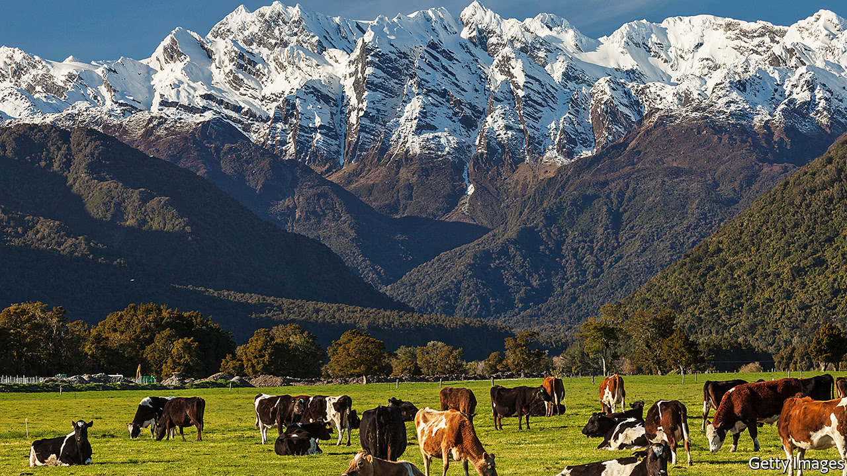

**Are you interested in Agriculture and/or Horticulture?**

If you are interested in working in any Primary Industry, Te Aho o Te Kura Pounamu can offer the opportunity to get a head start in your career. Agricultural unit standards from our specialist providers are available to work on at home. Students may begin these booklet based studies at any time of the year.

|  |  |  |  |  |
| --- | --- | --- | --- | --- |
|  | **Ag General** |  |  |  |
| **Unit Standard** | **Description** | **Credit Value** | **Category** | **Level** |
| 19139v3 | Gather and record information from a rain gauge, thermometer, and barometer; or weather station (L1) | 2 | Ag General | 1 |
| 19116v4 | Demonstrate knowledge of livestock behaviour and animal welfare | 3 | Ag General | 2 |
| 24542v2 | Describe the impact of an agriculture system on soils | 3 | Ag General | 2 |
| 22174v2 | Demonstrate knowledge of soils and fertilisers | 5 | Ag General | 2 |
| 19138v3 | Describe weather, climate and micro-climate characteristics, and interpret weather maps for a primary industry operation | 4 | Ag General | 2 |
| 19103v2 | Demonstrate knowledge of methods for promoting on-farm livestock health and health problems of livestock | 8 | Ag General | 3 |
| 22175v3 | Describe soil properties and their effect on plant growth | 6 | Ag General | 3 |
| 18v6 | Demonstrate knowledge of animal anatomy and physiology | 4 | Ag General | 3 |
| 28971v2 | Describe livestock reproductive processes and practices | 5 | Ag General | 3 |
| 28974v2 | Describe livestock selection for increased productivity | 4 | Ag General | 3 |
|  | **Dairy** |  |  |  |
| 18191v4 | Demonstrate knowledge of safe handling and health problems of dairy cattle, associated with milking | 3 | Dairy | 2 |
| 18192v4 | Demonstrate knowledge of how cows produce milk | 2 | Dairy | 2 |
| 18193v4 | Describe farm dairy design, and the farm dairy effluent system | 2 | Dairy | 2 |
|  | **Cattle** |  |  |  |
| 19081v4 | Describe annual feed supply and demand, methods to manage feed surpluses and deficits, and perform calculations | 4 | Cattle | 2 |
| 24623v2 | Demonstrate knowledge of breeds and classes of cattle, and identification and records for cattle | 2 | Cattle | 2 |
| 10082v3 | Demonstrate knowledge of rearing weaner or replacement cattle | 4 | Cattle | 3 |
| 19075v2 | Demonstrate knowledge of calving, and associated diseases and health disorders | 3 | Cattle | 3 |
| 24624v1 | Demonstrate knowledge of cattle genetics and selection | 5 | Cattle | 3 |
|  | **Sheep** |  |  |  |
| 19147v3 | Describe the activities and identify hazards in a wool shed during shearing from a farm perspective | 2 | Sheep | 2 |
| 24641v1 | Demonstrate knowledge of features, attributes, identification, and records for sheep | 2 | Sheep | 2 |
| 19149v3 | Describe lambing, and the procedures for assisting ewes having difficulty lambing | 4 | Sheep | 3 |
| 571v5 | Describe wool production in New Zealand | 5 | Sheep | 3 |
| 19157v2 | Demonstrate knowledge of sheep genetics, and ram selection | 5 | Sheep | 3 |
|  |  |  |  |  |
|  | **Apiculture** |  |  |  |
| 30791v1 | Demonstrate understanding of honeybee physical features, castes, bee stings and beehive health | 5 | Apiculture | 2 |
| 30796v1 | Demonstrate understanding of the process, role and significance of plant pollination by bees | 3 | Apiculture | 2 |
| 30798v2 | Demonstrate understanding of bees, the bee lifecycle and the adult bee behaviour patterns | 4 | Apiculture | 3 |
|  | **Horticulture** |  |  |  |
| 816v6 | Demonstrate knowledge of plant production in New Zealand | 5 | Horticulture | 2 |
| 829v5 | Demonstrate knowledge of plant nomenclature | 5 | Horticulture | 2 |
| 27210v2 | Identify and describe weeds, and methods of prevention and control | 6 | Horticulture | 3 |
|  | **Farm Dogs** |  |  |  |
| 19111v2 | Demonstrate knowledge of the types, breeds, uses, and health requirements of farm dogs | 4 | Farm Dogs | 3 |
|  | **Ag-Chem & Pest Control** |  |  |  |
| 27213v2 | Identify & interpret agrichemical product information and demonstrate knowledge of safety with agrichemicals | 5 | Ag-chem & Pest control | 2 |

If you any questions about these Unit Standards or you would like to enrol please contact [ces.lowe@tekura.school.nz](mailto:ces.lowe@tekura.school.nz)