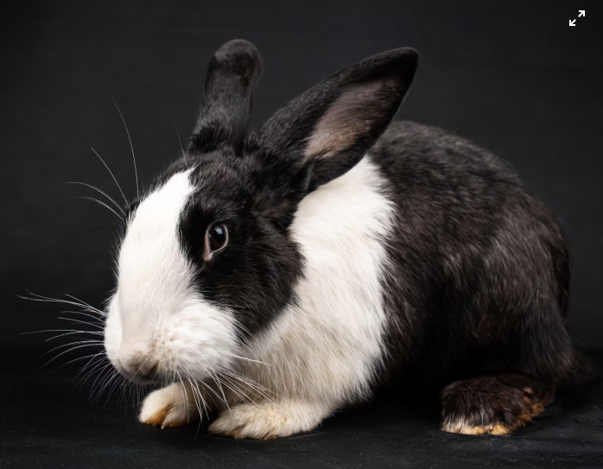
Animal Care by Distance

If you love working with and caring for animals, or you have interest in vet nursing this distance course from the Southern Institute of Technology may be a great introduction to this career pathway.
There are no mandatory units, and ākonga may choose from the units in the table below. All assessments must be completed for marking by the beginning of December.
Additional standards are available through Gateway if you have a suitable Gateway work placement. A strong interest in biology and ability in general science is recommended.
Unit Standards available are:

LEVEL 3
Unit Standard | Description | NCEA Level | Credits
19894 v4 | Demonstrate knowledge of zoonoses and their control | 3 | 5
32803 v1 | Describe rabbit feeding, health, housing and routine health procedures | 3 | 3
5180v7 | Describe companion animal anatomy, cells, body tissues and systems | 3 | 6
If you any questions about these Unit Standards or you would like to enrol please contact Seth.smith@tekura.school.nz

